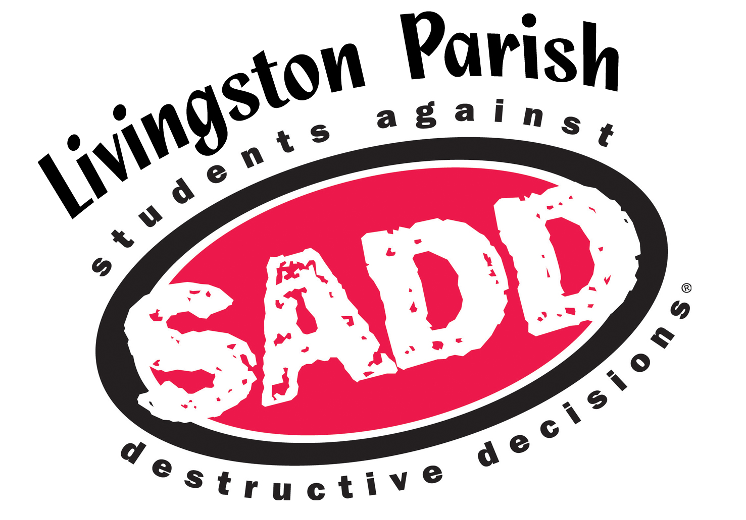
LP SADD
115A South Hummell Street
Denham Springs, LA 70726
(225) 380-5620
www.lpsadd.org

Student Leadership Council
2019-2020

About the SLC
Subtitle

The student leadership council is a community youth forum that works to further the mission of the organization. SADD’s mission is to empower young people to successfully confront the risks and pressures that challenge them in their daily lives.

SLC members grow and strengthen their leadership skills and gain travel, training, and public speaking opportunities. Members of the SLC work with their peers to promote health and safety initiatives in their schools and communities.

Duties and Roles of Members
- Plan, implement, and attend activities and events concerning issues at the campus, parish, and state level.
- Fundraise to continue the organization’s efforts.
- Work with peers to grow and start SADD chapters at their respective schools.
- Speak with members of the press or public on issues related to SADD’s mission.
- Provide the organization with youth insight and perspective on strategic planning, programming, trainings, and workshops.
- Serve as a role model for SADD students. This is achieved by having a positive attitude, and being alcohol, tobacco, and drug free. Members must abide by all traffic safety laws.
- Generally, the SLC meets on the third Thursday of each month.

Application Requirements
- Must be in 9-12 grade.
- Submit completed application via email (divy@lpsadd.org) no later than Monday, September 9, 2019.
- Include a letter of recommendation from a teacher, sponsor, or community leader.
- Include a copy of last year’s report card.

SLC Application

Date Click or tap here to enter text.

Name Click or tap here to enter text.

Gender Click or tap here to enter text.

Address Click or tap here to enter text.

Date of Birth Click or tap here to enter text.

School Click or tap here to enter text.

Grade Level Click or tap here to enter text.

If you have a SADD club at your school, how many years have you been a member? (Include the current school year.) Click or tap here to enter text.

Email Address Click or tap here to enter text.

Phone Number Click or tap here to enter text.

Parent/Guardian’s Name Click or tap here to enter text.

Parent/Guardian’s Phone Number Click or tap here to enter text.

Parent/Guardian’s Email Click or tap here to enter text.

Social Media
Social media plays a key role in our efforts to spread our prevention messages. We also use social media to communicate with members. Please list your accounts.

- Facebook (on your page, copy the link at the top and paste below)
Click or tap here to enter text.
- Twitter Handle
Click or tap here to enter text.
- Instagram Handle
Click or tap here to enter text.

Who is your role model and why?
Click or tap here to enter text.

We all deal with people we dislike. Why did you dislike a classmate or coworker and how did you deal with it?
Click or tap here to enter text.

How would your best friend describe you?
Click or tap here to enter text.

What movie or Netflix series deserves a sequel? Why?
Click or tap here to enter text.

If you could give your childhood self some advice what would it be?
Click or tap here to enter text.

What do you like the most about your school and why? What do you like the least about your school and why?
Click or tap here to enter text.

Defend your drug free lifestyle to someone who drinks alcohol at a party every weekend.
Click or tap here to enter text.

Prevention Ranking
Rank these topics 1-7 according to how prevalent they were last year at your school, with 1 being most prevalent.

alcohol
bullying
fighting
marijuana
prescription drug abuse
texting & driving
tobacco

Which topics are you most interested in working on?

Email to divy@lpsadd.org by September 9.

